Xi Xi’s My City Lesson Plans

Developed by the Student Ambassadors of One City One Book Hong Kong 2020
with guidance from Ms. Jessica Lee (Lecturer, English Language Education Department,
The Education University of Hong Kong)

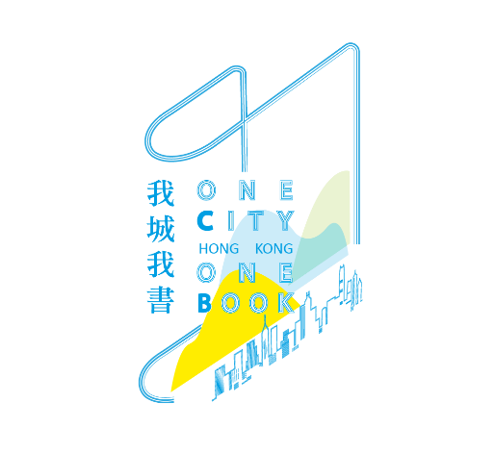
Table of Contents
Lesson Plan 1: Learning narrative techniques through Xi Xi’s My City 2
Lesson Plan 2: Show, don’t tell 12
Lesson Plan 3: Analyzing Braids………………………………………………………………………………………….. 33

Lesson Plan 1: Learning narrative techniques through Xi Xi’s My City

Developed by Miss Rachel Lai (Student Ambassador of One City One Book, 2020-2021) with guidance from Ms. Jessica Lee (Lecturer of Department of English Language Education, EDUHK)

Theme: Learning narrative techniques through Xi Xi’s My City
Topic: Tone of narration
Grade level: Junior Secondary 2 (F.2)
English level: Intermediate
Time: 35 minutes

Prior knowledge:
Students should have already known the synopsis of My City before attending the lesson, preferably already having read the whole book.
Students should have read Ch. 1 of the book.

Material/equipment needed:
See appendix.
They should also already have a copy of My City for reference.

Learning objectives:
After the lesson, students are able to
- Describe the tone of narration in Chapter 1 of My City by Xi Xi
- Analyze the effects of different narrative tones in the narration of a story

Duration | Procedure | MOI | Resources | Purpose
1 min | Preparation |  |  | To warm up students in an online setting for the lesson content. T may use this time to check student understanding to ensure they are on the page before proceeding
1 min | T starts the class by asking Ss to turn on their cameras and take out the classroom materials. | T – C | School LMS
2 min | Gaining attention
2 min | T asks Ss if they remember some information about the background of My City, such as its setting, the inspiration (from the life of 70s in Hong Kong), how the story was first published, the year when the book first appeared as a serial, and the author of the book. T may ask Ss to answer the questions by turning on their microphone. Alternatively, T may ask Ss to type into the chat box in the meeting software (e.g. Zoom or Microsoft Teams), if technology allows and Ss are reluctant to turn on their microphones. | T – C  S – C | Meeting software, e.g. Zoom, Microsoft Teams
8 min | Inform learners of objectives + Stimulate Recall of Prior Learning
2 min | T opens a Mentimeter and asks Ss to type what characters are involved in the book My City. T uses a word cloud to collect the answers. | T – C  S | Mentimeter | To start Ss’ thinking of Fruit’s characterization as seen in the novel
5 min | - T uses the grid function on Mentimeter and asks Ss to type the personality of Fruits based on their impression in reading the book.  - T asks if any Ss would like to share their ideas. T should prompt Ss to answer with reference to the context, i.e. give examples in the book.  - T wraps up and mentions that Fruits should be a young male character as depicted in the story. | T – C  S | Mentimeter
1 min | Inform the learning objectives: to understand and describe the tone of narration in Chapter 1 of My City, and to analyze the effects of different narratives tones in a story. T informs Ss the text to be analyzed today will be in Chapter 1. | T – C |  | To provide a signpost for Ss’ reading activity, in turn activating their schemata for further reading.
14 min | Present Stimulus Material + Provide Learner Guidance
1 min | T asks if any Ss remembers what Chapter 1 is about. If there is no answer, inform Ss that Chapter 1 is about the death of Fruit’s father. | T – C |  | To help Ss recall content to support later Ss comprehension.
2 min | T asks Ss to read the excerpt of Chapter 1 for five minutes. Before reading, T asks Ss to take note of the words or phrases that seem out-of-place in the context of death and annotate them as such on their device. T reminds Ss to think of what makes them think that the words or phrases they annotated are out of place, because they will be discussing with their classmates after solo reading. T reassures Ss that, depending on their progress in reading the excerpts, they may not be able to complete the task for both excerpts, but Ss should aim to at least complete the task for one of them. T asks if Ss have any problems prior to reading. | T – C | Appendix 1 | To inform Ss of the coming task and clarify any queries before silent reading.
5 min | Ss read the text. T turns off all camera for students and ask them to turn on their camera again once they are done, to signal they have completed both the reading material and the task. | S | Appendix 1 | To give Ss time to analyze the task on their own, building the foundation for subsequent groupwork
6 min | - T ensures everyone has completed the reading and has turned on their cameras.  - T asks students to share their findings for five minutes. If feasible (in accordance with the meeting software’s capabilities), ask Ss to discuss their findings in breakout rooms of groups of 3 to 4. Otherwise, T can “open the floor” for discussion, where Ss can freely open their microphones and respond to their peers.  - T gives the guidelines for sharing:  - What is the tone? Is it formal or informal? How do you know?  - Can you use another adjective to describe the narration?  - For weaker Ss, alternatives such as “serious”, “carefree”, “boring” can be provided.  - Why do you think Xi Xi has chosen to use this tone in the excerpt? If you were Xi Xi, would you use the same tone? Why or why not?  T concludes by saying Fruits narrates the chapter in a playful tone. For stronger Ss, T can mention Xi Xi is partly famous for writing in the style of “the spirit of the urchin”, and encourage Ss to look for other places where such “spirit of the urchin” can be found when they read the other parts of the novel. | T – C  S  GW | Appendix 1 | To give Ss time to collaborate and exchange their ideas on the use of narration techniques on the overall narration of the story.
8 min | Elicit Performance + Provide Feedback
6 min | T asks Ss to open Padlet and answer the two questions. T reminds Ss to give examples as appropriate.  - What does the playful tone show about Fruits? How does his tone make you feel about the story?  - What would happen if we change the tone to be more formal? How does it affect the narration?  T reminds Ss when there are 2 minutes and 1 minute left, respectively. | S | Padlet | To provide Ss with an opportunity to further reflect why Fruits is depicted as such even amid his father’s death.
2 min | T summarizes the ideas of the students’ answers on Padlet. T asks if Ss have anything to add, and they can turn on their microphones to answer directly in front of the whole class. | T – C  S – C |  | To conclude student discussion, pinpointing the main points raised by students. T may use the quality of responses (e.g. language use, story content mastery) to adjust the focus of later teaching.
2 min | Assess Performance + Enhance Retention and Transfer
1 min | T wraps up the content of the lesson by reiterating the learning objectives. T asks Ss to pay attention that the tone is also part of Fruits’ characterization. How Fruits speak not only affects how readers perceive the scene, but also how they view Fruits himself. | T – C |  | To conclude the lesson, giving students a time to connect the activities to the learning objectives mentioned at the beginning of the class.
1 min | T informs Ss of the post-lesson task:  Ss should choose another excerpt in Chapter 1, and rewrite it using another tone while keeping the point of view of Fruits. Ss should also prepare for the discussion questions, and T can either elicit further discussion in a subsequent class or ask for a written answer submitted through the school LMS. | T – C  S | Appendix 2, 3  School LMS

Appendix 1: Excerpts for student analysis

(1)
It is a Sunday. Sunday is just like any other day in the week: as a rule, various things happen, some novel, some extremely ancient. This day something ancient is taking place. In the early morning, Mother's eyes were already as red as tomatoes and swollen to the size of pumpkins. Seven or eight women are now standing around her, extending from various directions their plump or thin, long or short, right or left but equally white hands to support her. They're all wearing black robes, that's why their hands look white. However, one or two hands boast nail colours of an attractive red. Besides having extraordinarily eye-catching hands, this black-robed group share another characteristic —each and every one of them show a distinctive and easily recognizable face and head.

(2)
I'm standing alone beside some thick ropes. The ropes were originally lying motionless behind my heels, but someone in front of me suddenly gave them a tug, and they hurriedly started swimming away like water snakes. There are many more people standing in front of me. One of them, a big fellow, looks like a commander; maybe he had been a lieutenant during the war (gesticulating mode); he is giving orders. Try as I may, I cannot remember this person's name. Behind him is a row of heads; inside the heads, brains. I don't know any of the heads, nor do I know the brains. However, all the people who have come are extremely polite and well dressed, as though they have come here together for an important rehearsal. Oh, yes, the rehearsal is really running on a bit, so one man who has slightly less hair than the one next to him yawns, then moves his left arm and carries out the following movements in sequence:
1. speedily extending his arm to the front
2. bending his arm at the elbow salutation-style
3. fixing his eyes on his wrist

Appendix 2: Student re-writing (choose 1)

(1)
Facing me stands another row of black robes. On top of the black cloth-tents are three strange faces, all looking like lotus roots. One face (sympathetic mode) is diligently explicating the feelings behind the face, which means its eyes are shut and its left and right eyebrows are drawn close together. Another face (sorrowful mode) is ventilating air with either its mouth or its nose, it's hard to tell exactly. Yet another face (sad and helpless mode) reveals only two red ears; all other facial features, including spectacles, are neatly covered by a blue handkerchief with a white floral pattern.

(2)
On this day, the ancient event that is taking place has something to do with a coffin. As someone fixes his attention on his wrist-watch, a coffin is being carried down the stairs. The thick ropes and the coffin are fashioned, as deftly as you can imagine, into a lift. The texture of the ropes and the texture of the wood complement each other perfectly, and so do their colours. At this point, many people have a cold.
– Goodbye then
I say.

Suggested questions:
- What tone is your rewritten narration? What are the general characteristics of the narration?
- What are the differences between your rewriting and the original?
- In your opinion, which is better in terms of
  - Portraying the scene of the funeral of Fruit’s father?
  - Showing the characteristics of Fruits?
Give reasons for your answers.
- Do you think Xi Xi should use “the spirit of the urchin” to write such a serious topic? Why or why not?

Appendix 3: Student re-writing – suggested evaluation form

A (A+, A, A-)  Distinction | The re-writing demonstrates an excellent ability to grasp the language features when different tones are used. The answers to the discussion questions illustrate an excellent understanding of the reasons and effects when narration techniques vary. Overall, the assignment is very well-organized, with strong evidence to support the choices made in the assignment, presented in a logical way. The language used is very well chosen and appropriate, with minimal errors of English.
B (B+, B, B-)  Good | The re-writing demonstrates an ability to grasp the language features when different tones are used. The answers to the discussion questions illustrate an understanding of the reasons and effects when narration techniques vary. Overall, the assignment is organized, with evidence to support the choices made in the assignment, presented in a logical way. The language used is well chosen and appropriate, with few errors of English.
C (C+, C)  Satisfactory | The re-writing demonstrates some ability to grasp the language features when different tones are used. The answers to the discussion questions illustrate some understanding of the reasons and effects when narration techniques vary. Overall, the assignment is quite organized, with some evidence to support the choices made in the assignment, although sometimes not presented logically. The language used is appropriate, with some errors of English.
C-, D | The re-writing demonstrates minimally an ability to grasp the language features when different tones are used. The answers to the discussion questions illustrate a minimal understanding of the reasons and effects when narration techniques vary. Overall, the assignment is understandable, with adequate evidence to support the choices made in the assignment, sometimes not presented logically. The language used is restricted and occasionally contains inaccuracies. However, comprehension is seldom impeded.
F  Fail | The re-writing does not demonstrate an ability to grasp the language features when different tones are used. The answers to the discussion questions illustrate a poor understanding of the reasons and effects when narration techniques vary. Overall, the assignment is poorly organized, with insufficient evidence to support the choices made in the assignment. The arguments are illogical. Many and/or major grammatical mistakes which has made the assignment incomprehensible at times.  OR  No submission / submission beyond the deadline stipulated by the teacher for graded marking

Lesson Plan 2: Show, don’t tell

Developed by Miss Anson Chan (Student Ambassador of One City One Book, 2020-2021) with guidance from Ms. Jessica Lee (Lecturer of Department of English Language Education, EDUHK)

Topic/ Theme: Show, don’t tell
Level of students: Junior secondary
Lesson duration: 50 minutes
Students’ prior knowledge:
Basic understanding of what metaphors and similes are.
Learning objectives:
By the end of the lesson, students should be able to:
1. identify the technique of showing through a close study of similes used in the given excerpt
2. apply the technique of showing in a series of creative writing tasks
Time allocation | Procedures | Interaction  mode | Purpose | Resources
5 minutes | Pre-reading stage  T greets students.  T introduces Xi Xi and the learning objectives of the lesson:  - T chats with students by inviting them to think about why the writer uses Xi Xi as her pen name.  - T writes the Chinese words Xi Xi on the whiteboard and ask students if they notice anything special about the characters using their imagination.  - The Chinese character Xi resembles someone wearing a dress, which can be seen from the upper stroke which looks like the outline of a skirt, and the two lower strokes looking like a pair of feet standing inside a square (西西).]  - T asks Ss what they think of Xi Xi (What can you tell from her pen name?). T shares with Ss Xi Xi is a very creative writer. T may introduce other works by Xi Xi if time allows.  - T shares with the class today’s learning objectives, which are to learn from Xi Xi’s creative writing style—the technique of showing; they will have a chance to apply the technique in a series of creative writing tasks. | T-Ss | Arouse students’ interest and establish learning objectives | Whiteboard/ e-whiteboard
25 minutes | While- and post-reading stages  T asks the whole class to have a quick read of the excerpt (5 minutes)  T asks Ss to have two quick discussions after they have finished reading the excerpt.  Quick discussion 1 (5 minutes):  - What activity is going on in this part of the story?  a funeral  - Which words/ phrases show you that the setting is a funeral?  - “mother's eyes…as red as tomatoes and swollen to the size of pumpkins” (p.4)  - “all wearing black robes” (p.4)  - “this ancient event…has something to do with a coffin” (p.5)  - When the narrator says “Normally these heads and faces like to hide in the photo album” (p,4), what does the narrator mean?  Maybe Fruits is suggesting that these relatives do not visit each other very often and when they do appear in family gatherings, they only appear for “food” (meals for celebrating festivals).  - What tone is being used by the narrator in this paragraph?  An ironic tone is used.  For example, when Fruits says “Today they have broken with custom”, he seems to be scorning these relatives for breaking the pattern of only showing up for holiday meals. Another example can be found in Fruits’ description of his relatives’ insincere behaviour—how they all wear the same “ill-fitting though rather becoming black robes” and “flaunt their suddenly eye-catching hands” is actually the opposite of “acting solicitously”.  - Are there any descriptions which do not meet your expectations about a description about a funeral?  Free answers. From pp.4-5, we can see that Fruits mainly describes people who attend the funeral, mainly focusing on their appearances and gestures. The common rituals of a funeral and Fruits’ feelings are also revealed in later pages. But is Fruits really not sad? T can encourage students to read on and think about this.  (If the teaching is done online, T may share the excerpt using ‘share screen’ and have the students ‘annotate’ on the screen by highlighting the sentences which support their ideas.)  Quick discussion 2 (5 minutes)  T draws students’ attention back to the example of mother’s red and swollen eyes (p.4), and ask them:  1. What pictures are painted/ SHOWN in your minds when you read the two descriptions, ‘as red as tomatoes’ and ‘swollen to the size of a pumpkin’? What if I simply TELL you Mother’s eyes are red and swollen? Would the same pictures be painted/ SHOWN in your minds? Will this give you as much information as the former descriptions?  2. What literary technique is this?  T points out this is a writing technique to describe something to the readers by using a simile (by comparing the thing to something else) or a metaphor (by describing the thing as if it were something else), instead of telling the readers directly what qualities the thing possesses. With the help of similes and metaphors, a writer will be able to write a more vivid description which captures their readers’ imagination.  Quick revision on ‘similes and metaphors’ (2 minutes)  - T reiterates that today’s goal is to learn how to use similes and metaphors to SHOW one’s state of mind (instead of telling) and they will first learn to identify them.  - T asks Ss to recall ways to create similes (e.g. using ‘like’ and ‘as…as’ to link the thing you want to describe with something else which also shares similar qualities—The world is like a stage) and metaphors (e.g. by saying something IS something else which shares similar qualities—The world is a stage).  Exercise for students (2 minutes)  - Invite students to find other examples of ‘similes’ in the following paragraph on p.5:  By the side of these three faces, slightly apart from them, stands my aunt Liberty all by herself. As I look more closely, I realize that my sister Braids is standing beside her. My aunt Liberty’s posture is like that of a depressed scarecrow standing on a rock. Her mouth is shut, tightly shut. My sister Braids is holding onto one end of her robe, her head buried in its folds. Occasionally she shows her temple and her neck, like a squirrel. The tissue paper in her hand has turned into bits of cotton wool, which she pressed on her mouth, after a while, on her nose.  Discussion with students (5 minutes)  - Can you find any similes used to show the characters’ states of mind? Who is/ are being described?  - “My aunt Liberty’s posture is like that of a depressed scarecrow standing on a rock. Her mouth is shut, tightly shut.”  - “My sister Braids is holding onto one end of her robe, her head buried in its folds. Occasionally she shows her temple and her neck, like a squirrel.”  - Aunt Liberty and sister Braids.  - Why does Xi Xi use a scarecrow to describe Aunt Liberty and a squirrel to describe Braids? What do the characters have in common with a scarecrow and a squirrel respectively?  - A scarecrow usually has a stitched mouth. The simile here compares the tightness of Liberty’s mouth to a scarecrow’s stitched mouth in order to show how Liberty is holding her emotions.  - For Braids, a squirrel is used to describe her shyness. Braids ‘buries’ her face in her aunt’s robe and only shows her face occasionally.  - Do you like reading these kinds of descriptions compared to descriptions which tell you something directly? Why?  Free answers. Encourage Ss to justify their views with reasons.  Wrap-up (1 minute)  T wraps up the lesson:  ‘We have learnt that using similes and metaphors is a way to describe something and these expressions can be used to describe one’s state of mind, as shown in Xi Xi’s work. Having identified some examples, you’re now ready to try out this writing technique in your own writing.  And what we are going to do next is to learn about how to create good similes and metaphors and use them in our writing’  Teacher proceeds to the creative writing practice. | SS  T-Ss  T-Ss  T-Ss  SS or Ss/ Ss  T-Ss | To facilitate students’ understanding of the excerpt  To help students notice the use of similes and metaphors and the effect they create | Excerpt from My City’s Chapter 1, pp.4-5 (See Appendix I)
20 minutes | Creative writing practice for students  Task 1 (10 minutes)  T asks students to work on the worksheet (individually/ in groups).  T asks Ss to complete the following table by studying closely the metaphors used to describe Mother’s eyes, Aunt Liberty and Braids?  What/ who is being described? Qualities being emphasized What is being used to emphasize these qualities (hint: it should be something which has similar qualities) The class of things being used as a simile/ metaphor (choices: familiar objects/ food/ animals, etc.)  Mother’s eyes Red Swollen - tomato - pumpkin food  Aunt Liberty’s mouth tightly shut - scarecrow familiar objects  Braids’ shyness Brief appearance of her face - squirrel animal  T asks Ss to think about why these things are used to create the similes and metaphors. Do they make good similes and metaphors? Why?  Tasks 2 and 3 (10 minutes)  - T tells students they can finish these writing tasks at home if they cannot finish them in class.  - T tells Ss they will try their hand at creating similes and metaphors and using these literary devices in a creative writing task. | SS or Ss/Ss  T-Ss  T-Ss  SS | To help Ss understand what makes good similes and metaphors and provide guided and independent practice opportunities | Worksheet for Creative Practice and self-evaluation form (see Appendices II and III)

Appendix I – excerpt from Xi Xi’s My City, pp.4-5
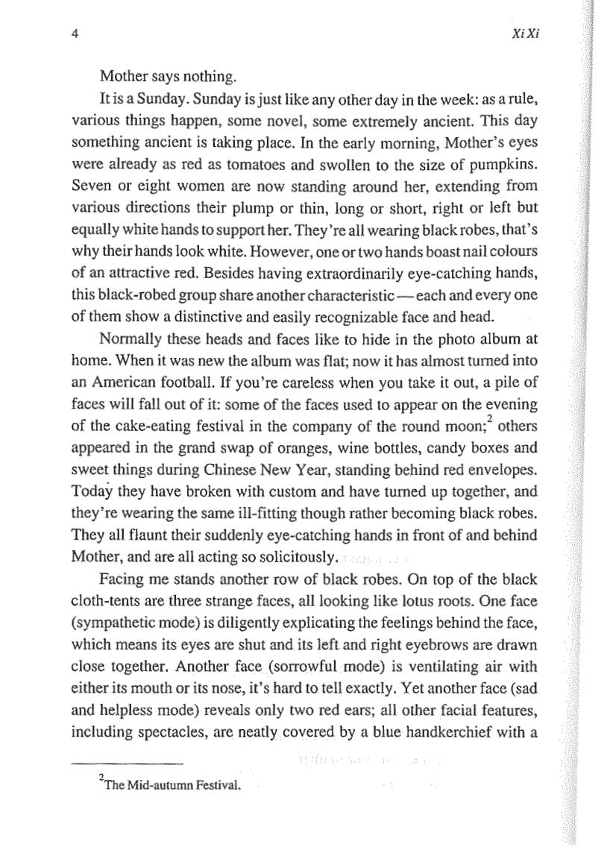
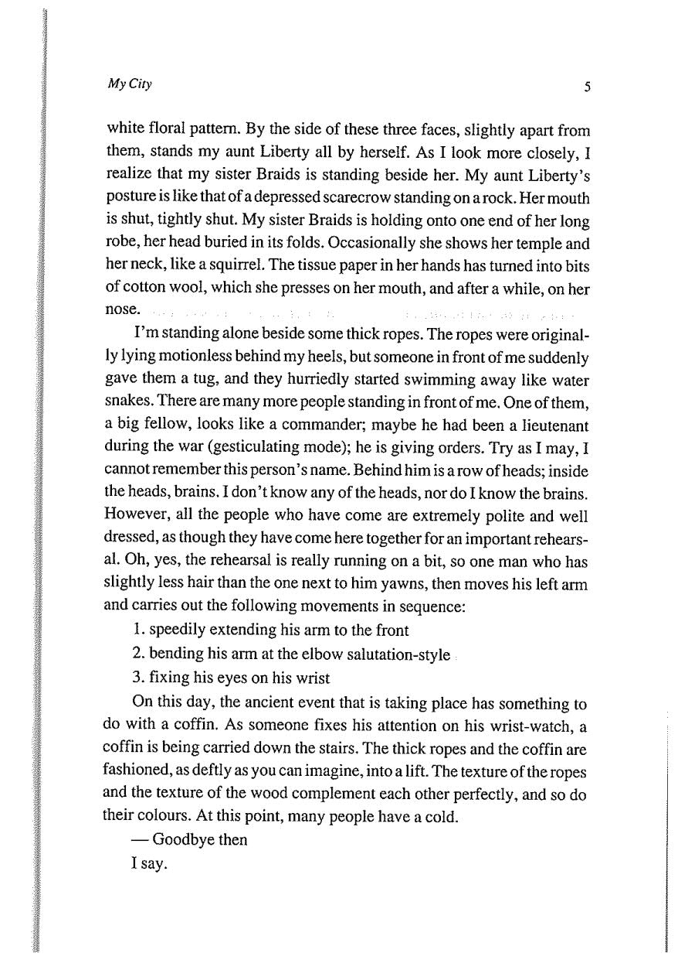
Appendix II—Worksheet for Creative Writing Practice
Task 1-What makes a good simile and metaphor?
Complete the following table to take a closer look at similes and metaphors used by Xi Xi when describing the characters. This will help you understand how good similes and metaphors are created. The first one has been done for you as an example.
What/ who is being described? | Qualities being emphasized | What is being used to emphasize these qualities (hint: it should be something which has similar qualities) | The class of things being used as a simile (choices: familiar objects/food/ animals, etc.)
Mother’s eyes | Red  Swollen | - tomato | food
Aunt Liberty’s mouth
Braids’ shyness

Now, you may have some ideas about how to come up with good similes/ metaphors. As a further practice, can you think of a simile or metaphor to describe the state of mind of the following character from the Japanese cartoon ‘Chibi Maruko-chan’?
Situation: Chibi Maruko-chan and her classmates are laughing at the monitor for his odd facial expression after he learned that no one wanted to vote him as the monitor in the new school year. Create a simile/ metaphor to SHOW the monitor’s state of mind. Use the table below to help you.
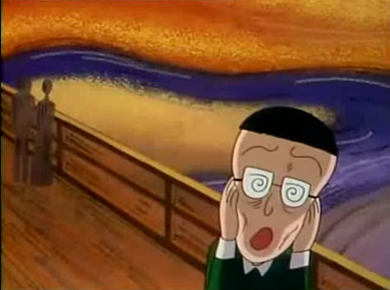

What/ who is being described? | Qualities being emphasized | What is being used to emphasize these qualities (hint: it should be something which has similar qualities) | The class of things being used as a simile/ metaphor (e.g. food, familiar objects, animals, etc.)

Write your description here:

Task 2 – Guided practice
The following table helps you construct creative similes/metaphors with the given ideas.
What/ who is being described? | Qualities being emphasized | What is being used to emphasize these qualities (hint: it should be something which has similar qualities) | The class of things being used as a simile/ metaphor (e.g. food, familiar objects, animals, etc.)
 |  | A deflated balloon
A man who is too excited and keeps talking and laughing loudly on a bus.
 |  |  | Insect
 | Feeling of nervousness

Write your descriptions here:

Task 3-Independent writing: My family at the dining table
When was the last time you had dinner with your family members? Describe the states of mind of your family members during the dinner in not less than 100 words. Again, you may use the “simile and metaphor” table above to help you. Upload your work to the online platform specified by your teacher to share your writing with your classmates.

End of worksheet

Suggested answer
Task 1-What makes a good simile and metaphor?
Complete the following table to take a closer look at similes and metaphors used by Xi Xi when describing the characters. This will help you understand how good similes and metaphors are created. The first one has been done for you as an example.
What is being described? | Qualities being emphasized | What is being used to emphasize these qualities (hint: it should be something which has similar qualities) | The class of things being used as a simile/ metaphor (choices: familiar objects/ food/ animals, etc.)
Mother’s eyes | Red  Swollen | - tomato  - pumpkin | food
Aunt Liberty’s mouth | Tightly shut | - scarecrow | familiar objects
Braids’ shyness | The brief appearance of her face | - squirrel | animal

Now, you may have some ideas about how to come up with good similes/ metaphors. As a further practice, can you think of a simile or metaphor to describe the state of mind of the following character from the Japanese cartoon ‘Chibi Maruko-chan’?
Situation: Chibi Maruko-chan and her classmates are laughing at the monitor for his odd facial expression after he learned that no one wanted to vote him as the monitor in the new school year. Create a simile/ metaphor to SHOW the monitor’s state of mind. Use the table below to help you.

What/ who is being described? | Qualities being emphasized | What is being used to emphasize these qualities (hint: it should be something which has similar qualities) | The class of things being used as a simile/ metaphor (e.g. food, familiar objects, animals, etc.)
the monitor’s reaction to the news | shocked/devastated | The agonised face in ‘The Scream’ | Familiar object (an iconic painting)

Write your description here:
The monitor’s face looks exactly like the agonised face in the “The Scream”.
Task 2 – Guided practice
The following table helps you construct creative similes/metaphors with the given ideas.
Free answers. The first one has been done as an example.
What/ who is being described? | Qualities being emphasized | What is being used to emphasize these qualities (hint: it should be something which has similar qualities) | The class of things being used as a simile/ metaphor (e.g. food, familiar objects, animals, etc.)
My brother learned he was not selected for the soccer match. | Loss of self-confidence | A deflated balloon | Familiar object
A man who is too excited and keeps talking and laughing loudly on a bus.
 |  |  | Insect
 | Feeling of nervousness

Write your descriptions here:
e.g. My brother felt like a deflated balloon after learning he was not selected for the football match.

Task 3-Independent writing: My family at the dining table
When was the last time you had dinner with your family members? Describe the states of mind of your family members during the dinner in not less than 100 words. Again, you may use the “simile and metaphor” table above to help you. Upload your work to the online platform specified by your teacher to share your writing with your classmates.
Sample text

The dinner I had last night was delicious yet horrible.

Last night our family gathered in Grandma’s place to celebrate the Mid-Autumn Festival. As expected, a big feast was prepared for such an important occasion. There was a salt-rubbed chicken, a big lobster served with stir-fly vegetables and other delicious dishes that we would not eat on a normal day. All these yummy dishes were made by the chefs in our family- my oldest aunt and my youngest aunt.

After the dishes were placed on the table, we ate quietly as usual, as we had nothing to talk about. However, there would always be someone who wished to start a conversation among the family members. And that someone was usually my dad. “We got two dishes of water spinach here but cooked with different sauces”, said my dad causally. Normally, my two aunts would not have eye contact with each other and avoid talking to each other as they have different opinions over almost everything. Nevertheless, upon hearing my dad’s remark about the two dishes of water spinach, my oldest aunt felt an urge to give a response, “Mine was bought from City Super. No pesticide added.” My youngest aunt, in turn, scoffed and replied, “Do you really think everything from so-called high-end supermarkets like City Super is good?” During the one-hour dinner, it seemed like we were witnessing a battle between the vegetables and the lobster, just like how ingredients were being stir-fried in a wok. It was amazing to see how my oldest aunt’s face turned as red as a lobster while my youngest aunt was just like the stir-fry vegetables, not losing her greenness even when being cooked in a hot wok.

In the end, my two aunts left with their respective children without washing the dishes. The dining room was filled with an awkward silence after their departure. I hope this dinner would not become a usual sight for all our family meals in the future.
End of worksheet

Appendix III
SELF-EVALUATION FORM

Circle the number which best describes your performance 3=excellent; 2=good; 1= OK; 0=needs more work

Writing Technique
- I used the technique of showing instead of telling to when describing a person or his/ her state of mind 3 2 1 0

- I described a person or his/ her state of mind with a simile/metaphor based on common qualities they share 3 2 1 0

- I used creative or original similes/ metaphors to make my descriptions more interesting to read 3 2 1 0

Language
- I used adverbials of time and place to establish the setting of the story 3 2 1 0

- I used specific thinking, verbal and action verbs to give details about what characters think, said and did 3 2 1 0

- I used tenses appropriately (e.g. simple past tense to show an event or an action which happened in the past and simple present tense to make a certain part of a narrative feel more “alive” and “immediate”) 3 2 1 0

Organisation
- I gave my narrative a recognisable structure (orientation sequence of events evaluation or a recognisable opening, middle and end) , making it easy to follow and understand 3 2 1 0

- I connected the ideas in my story logically with suitable connectives 3 2 1 0

Lesson Plan 3: Analyzing Braids
Lesson Plan developed by Anson Chan (Student Ambassador of One City One Book 2020) with Ms. Jessica Lee (Lecturer in the Department of English Language Education, EDUHK)
Topic: Analyzing fictional characters and providing literary evidence
Level of students: Junior secondary
Lesson duration: 45 minutes
Prior knowledge: Adjectives for describing character and personality
Resources:
- Copies of or excerpts from My City by Xi Xi.
- Contact onecityonebook@eduhk.hk to obtain these resources.
By the end of the lesson, students should be able to:
- identify character qualities and values using clues in the text
- understand some themes and meanings of My City by Xi Xi

Time | Procedure | Interaction mode | Purpose | Resources
5 mins | Pre-reading stage  T greets students.  T shows a photo of his/her own desk and shares his/her feelings and thoughts with the desk to arouse students’ interest.  After a few words of sharing, Teacher then states that “we are going to look at a different desk owned by another girl.”  T shows today’s learning materials- an excerpt taken from the 5th chapter of Xi Xi’s My City- to the class. | T-Ss | To arouse students’ interest | Photo of the teacher’s desk.  Excerpt from chapter 5 of My City by Xi Xi in English translation, with the paragraphs numbered.  Contact the One City One Book project to obtain copies or excerpts of My City.
15 mins | Reading Stage  T should:  - briefly introduce what Chapter 5 is about.  - let students read the excerpt.  - state that Xi Xi has used lots of objects and events to show what personalities and what kind of life Braids has.  - Introduce the learning objectives.  - state that the class will be working in 7 groups to analyse Braids the main character in Chapter 5 of My City, and each group is going to discuss one to two particular paragraph(s) assigned by the teacher  - show the table to be filled (see appendix I).  - In the table, students can use such phrases as “may be/can be/ could be” when they are not sure about their opinions/ they feel their evidence is not enough to support their opinions. | T-Ss  SS | To prepare students for the reading task and introduce the learning objective | Appendix I, below.
10 minutes | Demonstration  - Explain that studnets can complete the table using adjectives or phrases.  - Demonstrate how to complete one row of the table.  - T can ask students to look at the example in paragraph 2 -Braids  - has her pencil sharpener fixed to one of the corner of the desk and keeps sharpening her pencils fifty times a day (p.37), and then prompt them to think:  -why is she doing this, and do we learn about her from this sentence? (Pencils are the essential items for learning at school, and therefore symbolise academic study. And from the act of Braids unceasingly sharpening pencils, we can tell she cares about her study to an extent that she feels nervous and she may just calm herself by sharpening so many pencils. Or, we can think in another way that Braids may think she has to be well-prepared for her study with many good sharpened pencils as nice equipment.)  The teacher can also encourage students to look at something that seems trivial by asking: e.g.  -what can you tell from the fact Braids insists to have HB pencils? | T-Ss | To support students’ learning
15 minutes | Activity  - Students work in groups while teacher joins each group’s discussion from time to time to assist.  - After the time is over, each group can report what they have written. Teacher will lead discussion, asking questions like “do you agree that the word(s)/phrase(s) this group has just suggested are applicable to Braids? If you disagree, why?” | Ss-Ss  Ss-Ss | To share ideas and build skills. | Suggested answers, as provided in Appendix II.
 | Conclusion  T concludes that whenever we analyze a character we have to use literary evidence. Otherwise the observation may not be convincing.  Then T can introduce a post-reading activity as homework or an extended class activity. | T-Ss | To summarize and prepare for further development.

Optional post reading activity 1: Draw Braids

Every student will become a comic artist or illustrator in this activity.

After discussion Braids’s traits, students have a picture of what Braids is like. Therefore, students may draw Braids in their own style and write a few sentences to explain her appearance. Then the work could be uploaded to an online platform, either at the school or the one associated with the One City One Book project.

Optional post-reading activity 2: Share your Desk

Teacher can introduce the activity by talking about Braids’s desk, asking questions like:

- What do you think her desk and room look like? Are they both large?
(Yes, as it is said in the first paragraph-”large enough for you to skip-rope on” and “the desk was standing alone in the middle of a large room.” )

- Can you tell whether her living condition is good or bad?
(With the discussed evidence about Braids’s desk and room, we know the room is spacious, which can be considered one of the qualities for having a good living condition. Also, “it is quiet” and the view is nice, because "strong, healthy guava fruit” can be seen outside the window.)

- What style does this desk seem to be? A Western one like those we see in Ikea?
(Probably a western one like the one we use nowadays, as it is rectangular. A Chinese desk usually has no drawers or few drawers.)

Students are instructed to take a photo of their desk at home and write a caption with a few sentences. Then, they will be posting the photo to an online platform and giving a presentation in class.

T provides guiding questions like:
- How long have you been using this desk?
- Did you get to choose it when buying this?
- Whether yes or no, do you like this desk?
- Do you want to throw it?
- How often do you use it?
- Are you a person who likes to study or work at your desk?
- If not, where is the place for you to study?

The activity doesn’t require students to make a comparison to Braids’s desk. They just need to describe their own desk and studying habits in this short writing task. This activity is intended as an opportunity to have students know further about each other’s learning and invite them to reflect on themselves.

Optional post-reading activity 3: Write a letter to Braids

This activity prompts students to reflect on their own school life. Since students are going to give advice to Braids in a letter, they have to recall and reflect on the study methods they have been using before making any suggestions.

In chapter 5, Braids seems to be very nervous and pressured about her studies as shown in the book. Even if she has planned herself a timetable for play and work, she doesn’t seem to be leading a happy healthy life that a normal primary school student is supposed to have. With this said, students can play write to Braids showing care for her, as well as giving tips for studying.

Appendix I: Analyzing Braids in Chapter 5 of My City by Xi Xi

Complete the following table to help you understand the character Braids.

Group | Paragraph | Detail from the Book  (hint: the “what” includes what Braids says, does, thinks and does)  (Remember to use simple present tense when citing examples) | What does the detail tell you about Braids?
A | 2 | (teacher’s demonstration)  Braids has her pencil fixed at her desk’s corner and sharpens her pencils fifty times a day. | She may be anxious about her studies.
B | 3
C | 4
D | 5-6
E | 7
F | 8-10
G | 11-12

Appendix II: Suggested Answers

Group | Paragraph | Detail from the Book | What does the detail tell you about Braids?
A | 2 | (teacher’s demonstration)  - Braids has her pencil sharpener fixed at her desk’s corner and sharpens her pencils fifty times a day.  - Braids wants pencils as a gift for her every birthday. | She may be a person so anxious about her studies.  She is really concerned about her study that she even asks for pencils for her birthday gift, something that are beneficial to her study, of which Braids may think
B | 3 | - Braids has a bookshelf that is packed with exercise books.  - Most Braids’s book are “loosely-leaf linked” | She values study so much to an extent that she seems to have no time reading books that are not academic-related.  Braids is a hard working student, which can be reflected by her act of studying so often.
C | 4 | - Braids sticks to her schedule and regularly does her homework at 2pm on time every day. | Braids is very disciplined.
D | 5-6 | - Braids hangs a clock with a rope around her neck to remind herself of when to do what.  - Braids makes herself a timetable for work as well as play, where she switches to play and to work in every 30 minutes | She is very anxious she will delay her next task, that is her study.  She is well-disciplined, maybe abnormally, as she knows the importance of the time for work and relaxation, but she is like a robot programmed who keep doing things between play and work with a timer set. Also it doesn’t seem that she actually feels relaxed.
E | 7 | - Braids picks onions in order to make the belief she has heard from others happen. | She is in some way superstitious.
F | 8-10 | - Braids cherish every word from her class teacher that she keeps living them up.  - Braids writes “travel around the world as her second wish” | She is a typically obedient student.  Braids shows another interest other than study here. Braids has a concern and curiosity towards different places in the world.
G | 11-12 | - Braids sometimes falls asleep on her dictionary and “had her sandwiches”, referred to the academic books, in her every meal | Braids gives herself some time for play, but not for taking a rest. She is highly concerned about her allocation of time and study.  Also, Braids’s life is fully occupied by her study like meals.

