Xi Xi’s My City Lesson Plan
Sample Creative Writing Lesson

Developed by Collier Nogues (MFA, UC Irvine)

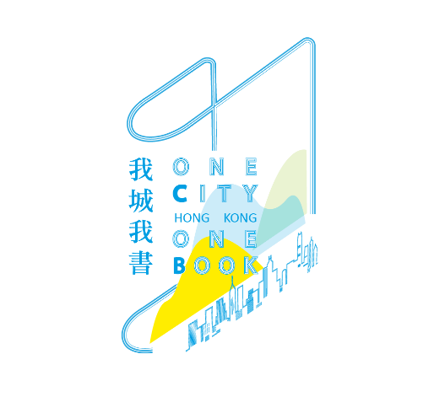

我城我書 / One City One Book Hong Kong
Sample Creative Writing Lesson

Topic
- My City by Xi Xi

Target Audience
- Secondary 4-6, adaptable to Secondary 1-3

Learning Objectives
- Understand characterization based on examples from My City
- Employ characterization in creating a character
- Reflect on differences in perspective

Reading or Pre-reading
- Chapter 2 of My City by Xi Xi (in English, trans. Eva Hung) (8 pages long)
- Contact One City One Book Hong Kong to receive a loan of textbooks or excerpts. The audiobook version (in Chinese) also available here.
- Lesson focuses on a brief excerpt, included below.

Estimated Total Lesson Time
- 1 hour

Task and Time | Process
- Introduction and Group Discussion  (5 mins) | Introduce Liberty as the protagonist of this chapter.  We know that she:  • likes to draw (she “wants to draw” and checks her picture book to make sure she is accurate about how many toes a hippo has)  • is generous (she buys a raffle ticket from the tired boy; she buys washing powder from the “dispirited” salesgirls even though it is for washing machines and she does not have a washing machine or room for one),  • “has a trunk” full of things. What kind of things does she have?  Students answer by listing the things, or teacher points them out.
- Creating Contrast  (5 mins) | Show that Liberty’s character contrasts with that of other people, as introduced at the top of p18:  “There is this person whose view of everything in the world is as follows:  …  The things in Liberty’s apple crate are worth 0 points. That is why Liberty’s apple crate is in fact a garbage bin.”  But Liberty cares very much about the things in her apple crate—she keeps them safe in the crate, and stacks them carefully and puts them back where they belong (the picture book is “somewhere near the bottom” and she has to put all the other things back each time she takes it out).  Ask: why do you think she takes good care of these things?  [students answer something like “they have special meaning for her”]  Ask: so do you think her apple crate is “in fact a garbage bin”?  [students answer ranging from “yeah” to “well, it depends who you’re asking” to “no! she loves those things!”]  Emphasize: it is a matter of perspective. Liberty loves these things, perhaps no one else would, the “person” at the top of p 18 definitely would not.
- Student’s objects  (15 mins) | Ask: are there any things that you keep that are worth 0 points on this scale?  Students make their own list and answer questions.  Why do you keep them? Where do you keep them? Try to write down at least five; if that’s difficult, think about things your parents or friends or siblings keep that don’t fit this scale. Write down as many as you can.  Feedback: Students share some of their list items.  Ask: do you think Liberty would appreciate your 0-point things?  [responses will range from “yes, she understands loving weird things” to “yes, if I explained them to her” to “I don’t know” to “no, she loves her own weird things”]
- Make a new scale  (15 mins) | Teacher and students together re-read the list of things and how many points they are worth.  Teacher holds up 5-6 objects/pictures of objects or shows objects on screen: which category does this thing fall into?  Things should be obviously part of one category or another (a tasty snack, a pretty flower, a piece of jewelry, a $100 bill, a fancy car, etc.)  Teacher holds up 5-6 objects that do not fall obviously into any of the categories (a hand-drawn valentine, a photo of a pet cat, a favorite cup, etc.). These should be things the teacher keeps because s/he loves them, but s/he should not reveal this yet. Students try to fit the objects into a “this person” category, perhaps coming up with creative reasons why.  Activity: Teacher asks students in small groups to make up a new scale of categories into which these objects might fit and assign them point values.
- Reporting Back  (5 mins) | Students share some of their categories and point values. Categories will likely be practical, and depending on the objects may reveal some attention to emotional value (“cup: things you can use to eat and drink with: 10 pts”; “valentine: expression of love: 100 pts,” etc.)  Teacher explains these are his/her “0-point” objects. For each object, teacher explains briefly why s/he keeps it, noting that if s/he were to make a new scale for these objects, it would be very personal.  Ask: do any of the objects you wrote down before, that you keep and are worth 0 points on Xi Xi’s “this person” scale, fit into the categories on your new scales?
- Creating a character  (15 mins) | Teacher explains that our next step is to each make our categories personal, so they fit our own beloved objects.  Using their group categories as groundwork, students find places for their own “0-point” objects, making new categories if necessary and assigning point values for each category.  Students write their own short piece modeled after Xi Xi’s (exactly borrowing her structure, if you like, especially in lower grades), beginning “There is this person whose view of everything in the world is as follows.”  At the end, they can write “This person is me, and my [container of things (answer to “where do you keep them from item 3)] is in fact a [noun replacing “garbage bin”].

Excerpt from My City by Xi Xi, translated by Eva Hung (Renditions Paperbacks, 1993).

There is this person whose view of everything in the world is as follows:

Things which make good displays, e.g. orchids, sculptures: 5 points
Things which satisfy your appetite, e.g. steaks, snails: 5 points
Things which you wear to show off, e.g. fur coats, diamonds: 30 points
Things which bring you a big reputation, e.g. masterpieces of art and literature: 100 points
Things which can be traded for a mention on the Queen’s Lists, e.g. charity, high official posts: 1000 points
Things which can be sold in future at an astronomical price, e.g. real estate, securities: 3000 points

The things in Liberty’s crate are worth 0 points. That is why Liberty’s crate is in fact a garbage bin.

(p 18).

